Template designed to assist in meeting the DEM Requirements for 2020 -2021

This document does not guarantee conformity of the content you provide.

The first few pages (with writing in red) are explanatory and will need to be erased before sending your portfolio.
.

To delete a page, simply click on it and press
“delete” on your keyboard. You may have to do this several times for it to work.

Use this space to write an introduction or to make a general presentation of your portfolio (favorite pictures, important events, summary of your year, your child’s projects, etc.)
Child’s name
Not mandatory

The portfolio must include a few comments from your child.

They can either write their own text or dictate their comments for you to include in their portfolio.

The comments should include things like:
- What they liked or did not like this year (or part of the year).
- What they found easy or difficult.
- What activities they would like to do again (or what they would like to change).
- Their favorite memory of the year.

The materials they like to use, their favorite games, why they like homeschooling, etc.
Child’s
comments

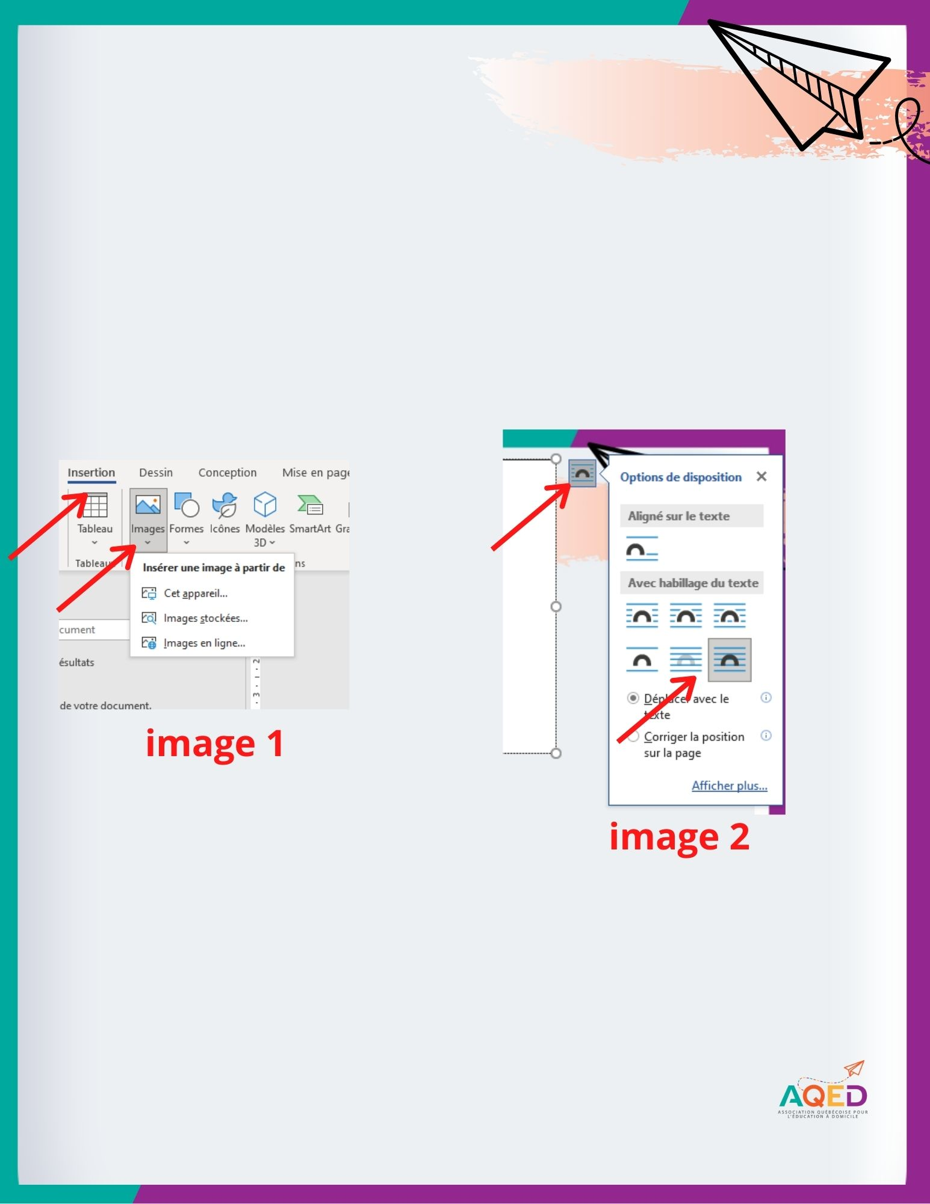
The pages that follow are templates into which you may insert your learning traces. A learning trace can be a picture, excerpt of a text, explanation of an activity your child completed, etc.
See image 1 for how to insert pictures into the document. The copy-paste option also works. Once you have added your picture, clicking on it will allow you to adjust the size, position, and tilt, if you wish. You can also go to the layout options to work the layout with text like shown on image 2.
If you make an error, simply hit ctrl + Z and the last action will be undone.

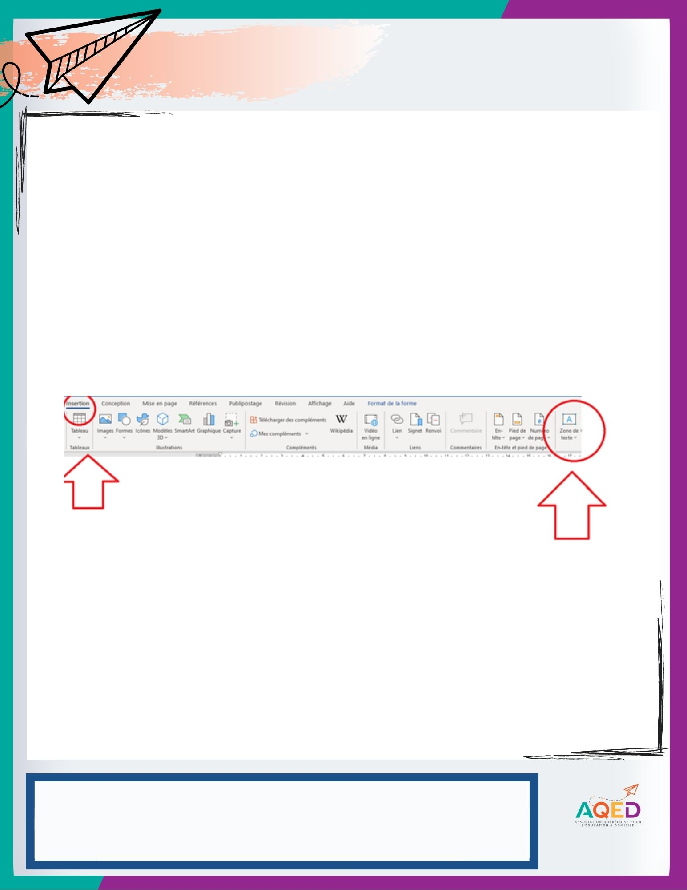
Subject: French, math, etc.
Competency: see list on the following pages

Traces of learning activities
Insert here the images or text excerpts that serve as your learning traces (2 to 3 traces total).
- Order from oldest to newest.
- Number them from 1 to 3.

If you want to add additional space in which to write, you can add a text box (in Word), by clicking Insert-->Text Box.

Learning context and educational intent :
1 - Brief description of the educational intent (what you hoped to develop in your child) and the learning context (how it was done). Make sure that you match the description with the correct trace (follow the numbers)
2 - Repeat as above for trace 2.
3 - Repeat as above for trace 3.

Comments on progress:
This space is for commenting on the child’s learning progress, using phrases such as: - has ease to... - has a hard time... - is autonomous in... - got better... - must work... -must use... - is now... - is using more and more... - is capable of... - is motivated by...

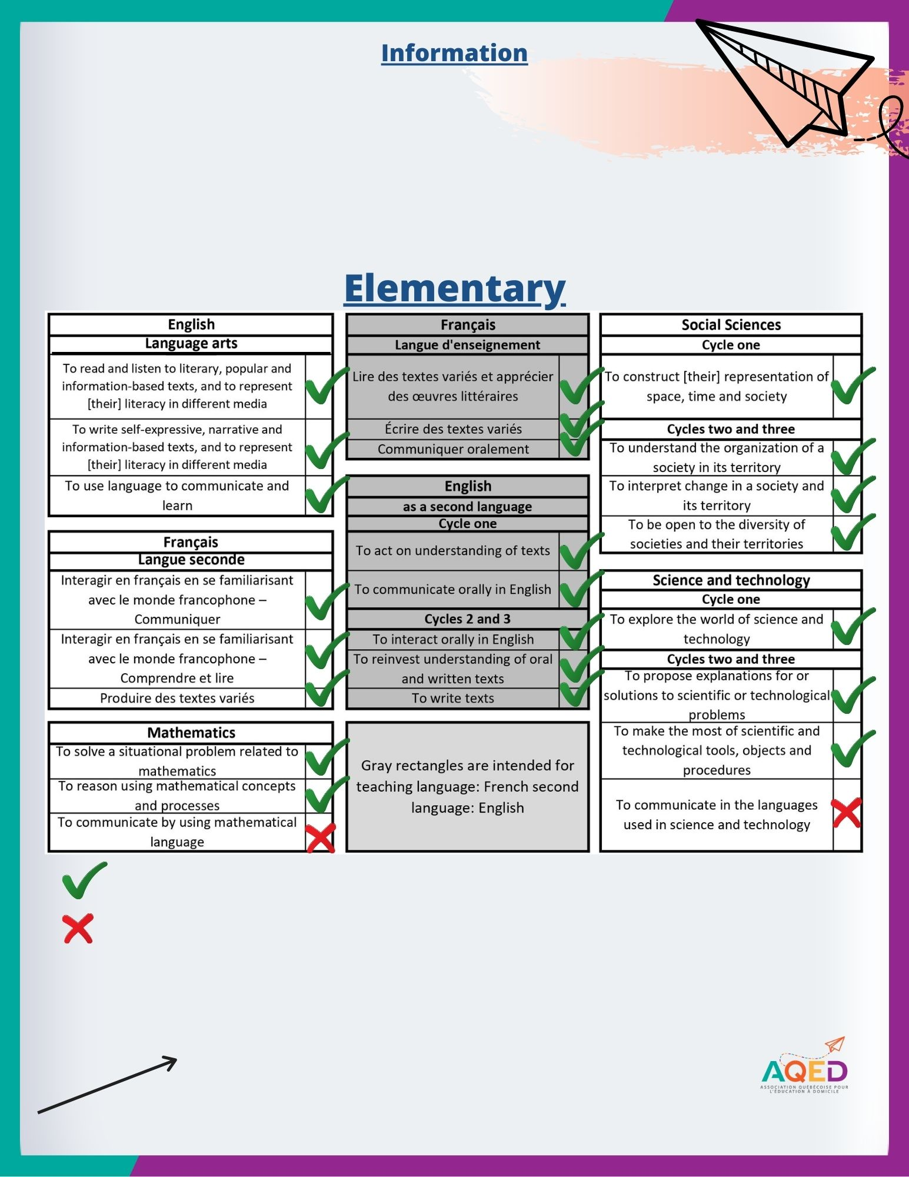
These are the compulsory subjects for homeschooling, as well as the competencies targeted.
Note that according to the document “Requirements with Regard to the Subjects and Competencies That Must Be Taught, Monitored and Evaluated in a Homeschooling Context” from the DEM, some competencies are integrated with others and do not require assessment.

= Learning traces must be included in the portfolio
= The traces are integrated with those of the other competencies. No assessment required. This competency should instead be subject to a feedback to the child. So, no traces needed!

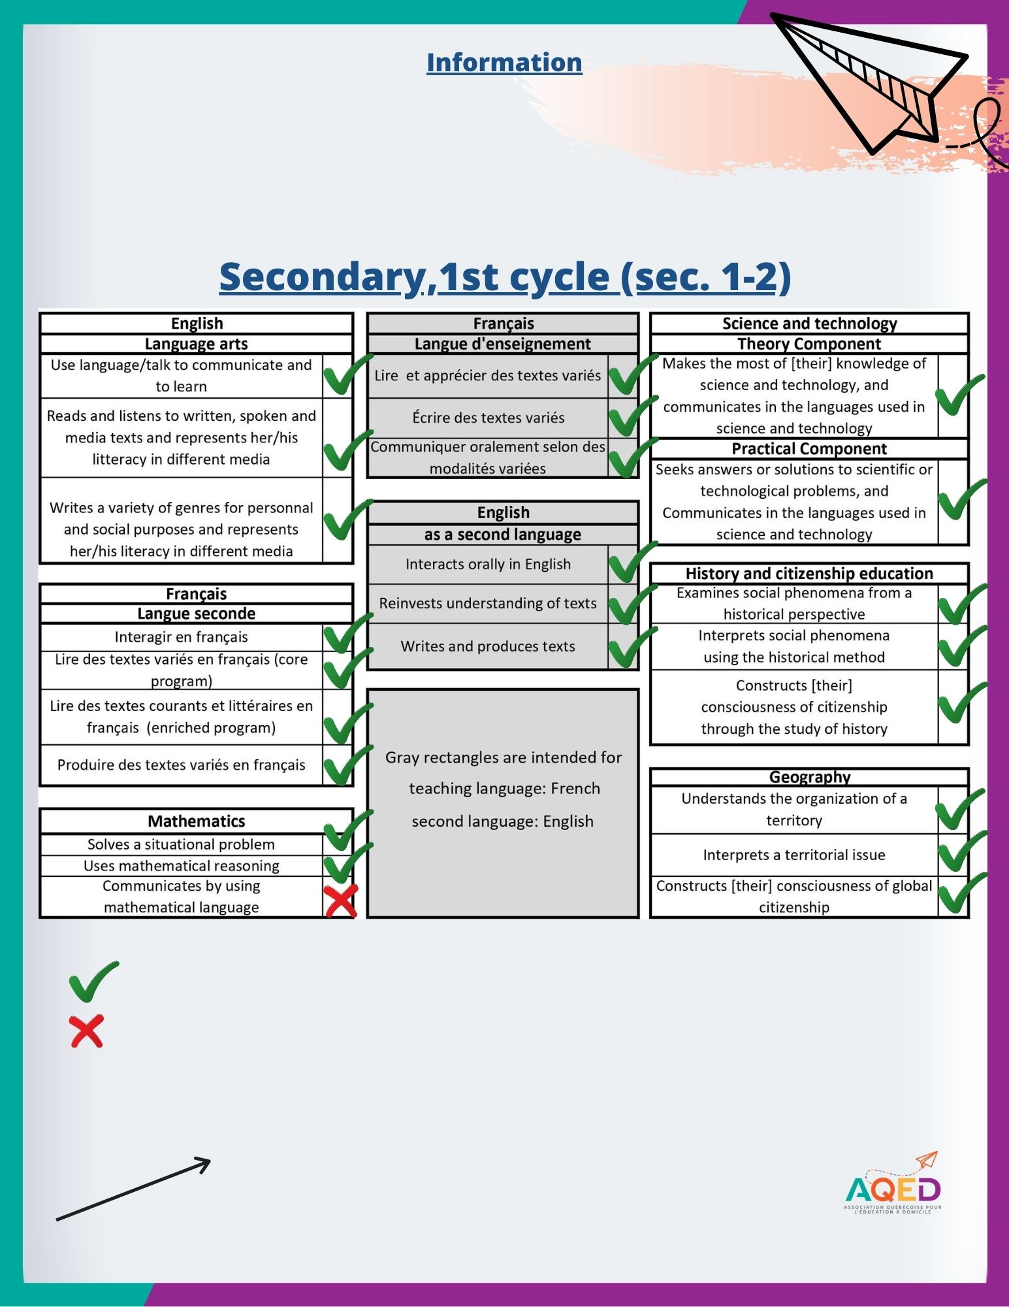
These are the compulsory subjects for homeschooling, as well as the competencies targeted.
Note that according to the document “Requirements with Regard to the Subjects and Competencies That Must Be Taught, Monitored and Evaluated in a Homeschooling Context” from the DEM, some competencies are integrated with others and don’t require assessment.

= Learning traces must be included in the portfolio
= The traces are integrated with those of the other competencies. No assessment required. This competency should instead be subject to a feedback to the child. So, no traces needed!

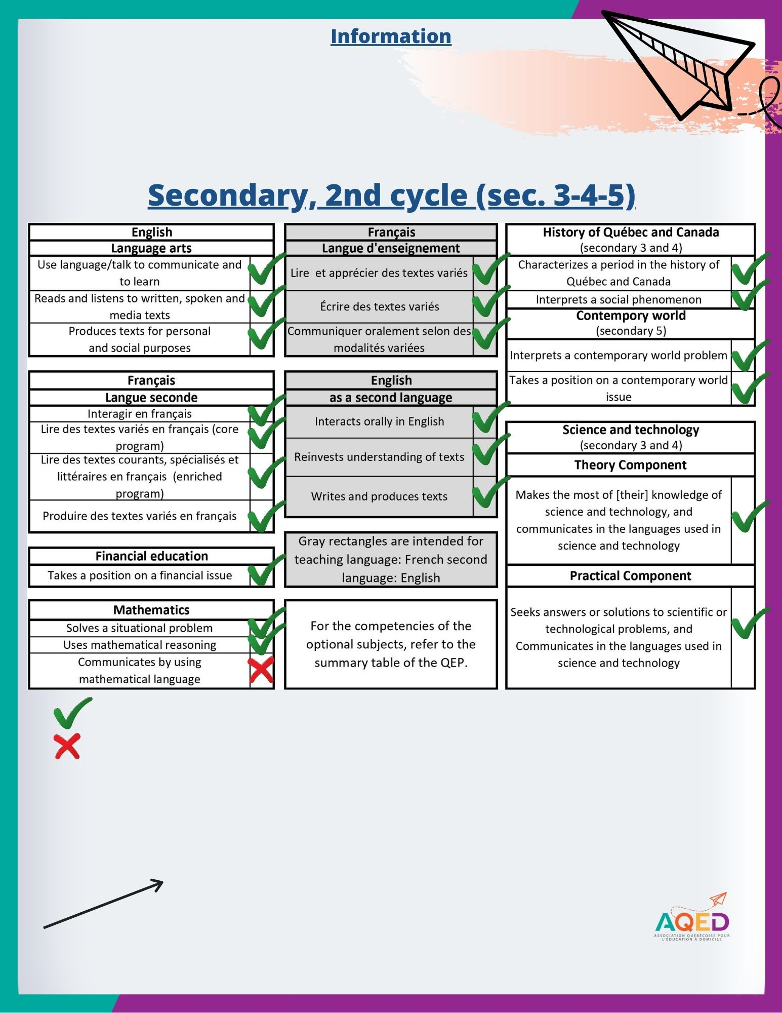
These are the compulsory subjects for homeschooling, as well as the competencies targeted.
Note that according to the document “Requirements with Regard to the Subjects and Competencies That Must Be Taught, Monitored and Evaluated in a Homeschooling Context” from the DEM, some competencies are integrated with others and don’t require assessment.

=Learning traces must be included in the portfolio
= The traces are integrated with those of the other competencies. No assessment required. This competency should instead be subject to a feedback to the child. So, no traces needed!

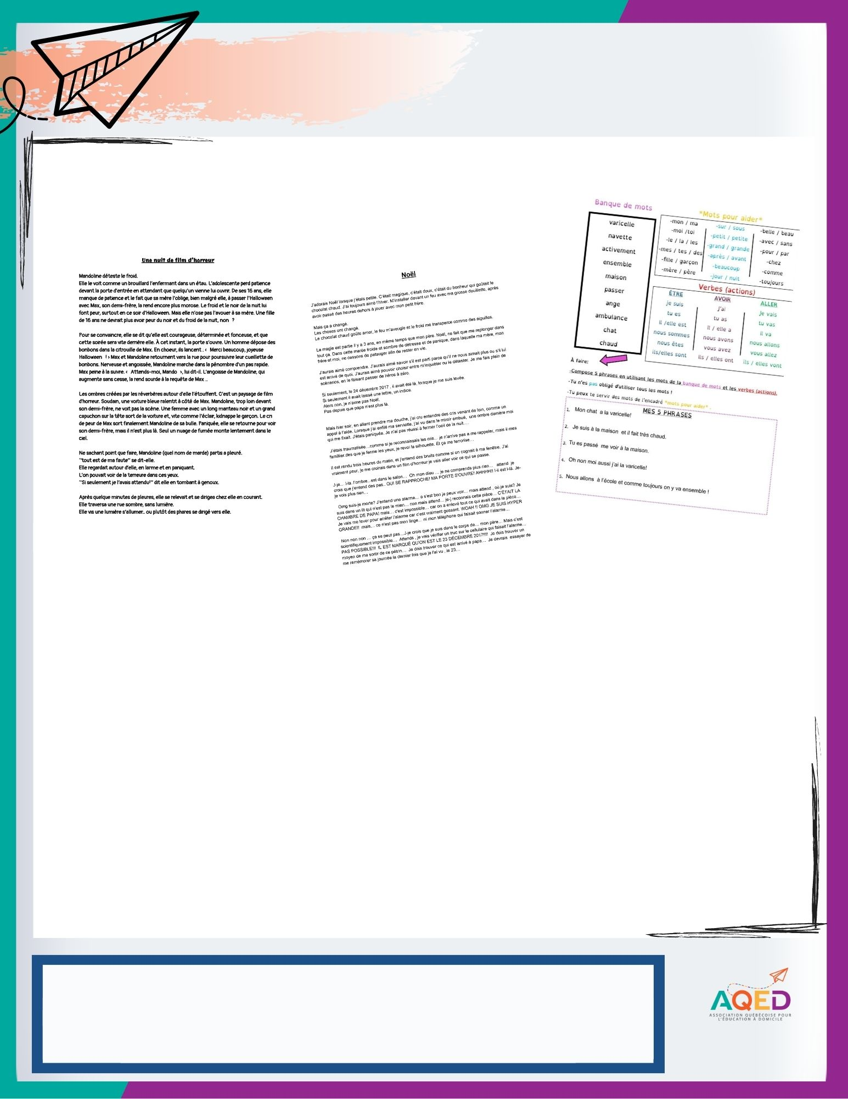
Subject: Français
Competency: produire des textes variés en français

Traces of learning activities

Learning context and educational intent:
1 - Excerpt from a Halloween story, made to work the story in 5 steps and to allow me to assess my child's level (strengths, difficulties and mastered notions).
2 - She had to complete the story that had been started. The goal was to work on writing and self-correction, and to allow me to see the evolution of the notions to work on and what was mastered.
3 - Examples of sentences written on a weekly basis, to practice vocabulary words and verbs.

Comments on progress:
I have noticed a nice progression in verb endings.
Errors are less frequent compared to last September.
Still in progress: past participles in general and the use of homophones.
Subject(s) evaluated by another method
(By School Board, private educational institution, licenced teacher, ministerial examinations)
Name of the subject(s) and method used:
If your child has had an assessment (e.g.: school board, private school, ministerial examinations...) you do not have to provide learning traces FOR THIS SUBJECT. Instead, indicate only: the name of the subjects in question, the assessment mode AND complete the “Comments on the child’s learning progress” section.
Example: Mathematics, School Board evaluation.

Comments on the child’s learning progress:

Conclusion

*Closing remarks. Choice of conclusion, NOT MANDATORY*

Subject:
Competency:

Traces of learning activities

Learning context and educational intent:
1-
2-
3 -

Comments on progress:

Subject:
Competency:

Traces of learning activities

Learning context and educational intent:
1-
2-
3 -

Comments on progress:

Subject:
Competency:

Traces of learning activities

Learning context and educational intent:
1-
2-
3 -

Comments on progress:

Subject:
Competency:

Traces of learning activities

Learning context and educational intent:
1-
2-
3 -

Comments on progress:

Subject:
Competency:

Traces of learning activities

Learning context and educational intent:
1-
2-
3 -

Comments on progress:

Subject:
Competency:

Traces of learning activities

Learning context and educational intent:
1-
2-
3 -

Comments on progress:

Subject:
Competency:

Traces of learning activities

Learning context and educational intent:
1-
2-
3 -

Comments on progress:

Subject:
Competency:

Traces of learning activities

Learning context and educational intent:
1-
2-
3 -

Comments on progress:

Subject:
Competency:

Traces of learning activities

Learning context and educational intent:
1-
2-
3 -

Comments on progress:

Subject:
Competency:

Traces of learning activities

Learning context and educational intent:
1-
2-
3 -

Comments on progress:

Subject:
Competency:

Traces of learning activities

Learning context and educational intent:
1-
2-
3 -

Comments on progress:

Subject:
Competency:

Traces of learning activities

Learning context and educational intent:
1-
2-
3 -

Comments on progress:

Subject:
Competency:

Traces of learning activities

Learning context and educational intent:
1-
2-
3 -

Comments on progress:

Subject:
Competency:

Traces of learning activities

Learning context and educational intent:
1-
2-
3 -

Comments on progress:

Subject:
Competency:

Traces of learning activities

Learning context and educational intent:
1-
2-
3 -

Comments on progress:

Subject:
Competency:

Traces of learning activities

Learning context and educational intent:
1-
2-
3 -

Comments on progress:

Subject:
Competency:

Traces of learning activities

Learning context and educational intent:
1-
2-
3 -

Comments on progress:

Subject:
Competency:

Traces of learning activities

Learning context and educational intent:
1-
2-
3 -

Comments on progress:

Subject:
Competency:

Traces of learning activities

Learning context and educational intent:
1-
2-
3 -

Comments on progress:

Subject:
Competency:

Traces of learning activities

Learning context and educational intent:
1-
2-
3 -

Comments on progress:

Subject:
Competency:

Traces of learning activities

Learning context and educational intent:
1-
2-
3 -

Comments on progress:

Subject:
Competency:

Traces of learning activities

Learning context and educational intent:
1-
2-
3 -

Comments on progress:

Subject:
Competency:

Traces of learning activities

Learning context and educational intent:
1-
2-
3 -

Comments on progress:

Subject:
Competency:

Traces of learning activities

Learning context and educational intent:
1-
2-
3 -

Comments on progress:

Subject:
Competency:

Traces of learning activities

Learning context and educational intent:
1-
2-
3 -

Comments on progress:

Subject(s) evaluated by another method
(By School Board, private educational institution, licenced teacher, ministerial examinations)
Name of the subject(s) and method used:

Comments on the child’s learning progress:

Conclusion

